**CHAPTER IV – SORTING & FILTERING (to manipulate)**

Designing the schema or structure of a database is the very first step in designing a database system. Database schema is about the structure of a database. In other words, how data is organized in a database. Data in a database is organized into tables that have columns and rows. Each column or field has a defined data type, and the tables are related to each other. The simplest way of understanding database schema is to think of it as the blueprint of a database. Before anyone can use a database to store and manipulate data, the database schema must first be designed. This process of database schema design is also known as data modeling.

Schema : Organization of grouping information and it’s relationship among them.

Database schema : Collection of data structures within a database.

In SQL SERVER, database schema is a collection of individual, but related, components (tables, fields, datatypes and keys) .

In PostgreSQL , database schema is a namespace with name database objects (Indexes, functions).

The important thing about Schema are ORGANIZATION and RELATIONSHIP.

* Organization of data in the form of tables
* Relationship between the tables.

A Component of database or schema object or components within a schema :

* Tables
* Columns
* Relationship : Data Relationship.
* Datatypes : Name and data types.
* Keys. : Unique object keys.

Schema Advantages:

1. Management : Schema provide logical grouping for database objects.
2. Accessibility : Enable greater accessibility to objects. (make it easier to access, and manipulate the objects)
3. Security : Offer a range of useful security features (Grant permission for access based on user access)
4. Ownership : Permit transfer of ownership between users.

Database schema can be broadly divided into three categories :

1. **Conceptual or logical schema** that defines entities, attributes and relationships. Also describes the structure of the entire database for all the users. **It describes the structure** in terms of entities and features of the entities and the relationships between them. An Entity Relationship Diagram (ER-D) is usually drawn to represent the logical schema of a database. At this level, details about the physical storage and retrieval of data are hidden, and the database structure is described only at a concept level.

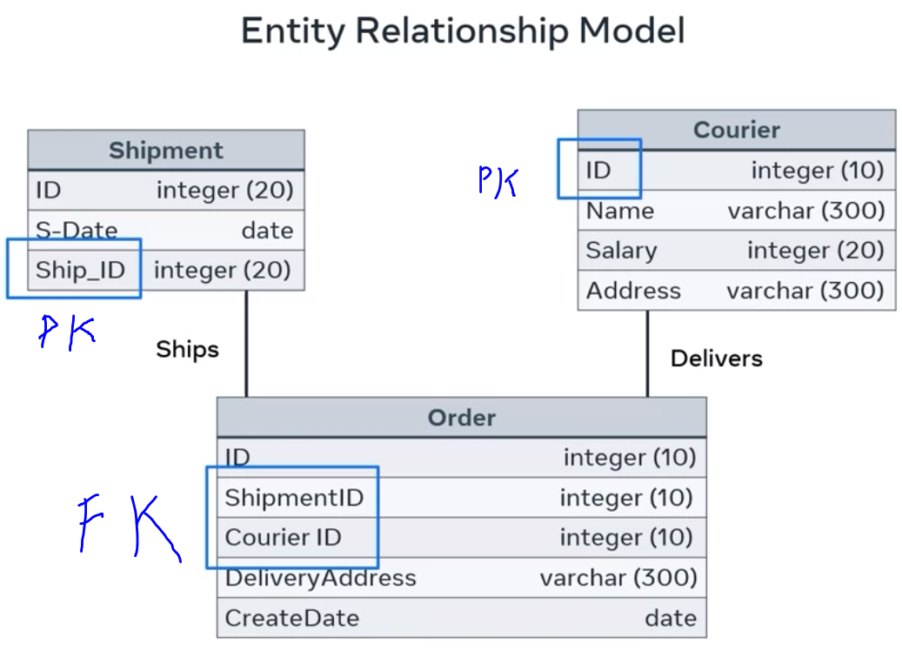

1. **Internal or physical schema** that **defines how data is stored in a disk/secondary storage**. In other words, the actual storage of data and access paths. The internal or physical schema describes the physical storage of the database. It represents the entire database but at a very low level. This means it describes how the data is really stored on disk in the form of tables, columns and records. It defines what data is stored in the database and how.
2. **External or view schema** that defines different user views. This schema only describes the part of the database that the specific user is interested in. It hides the nonrelevant details of the database from a user. For example, a user from the sales department will see only sales-related data in a database.

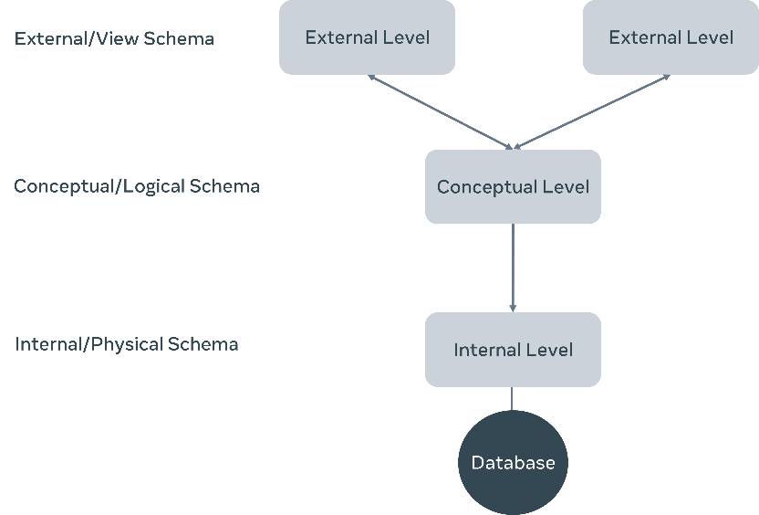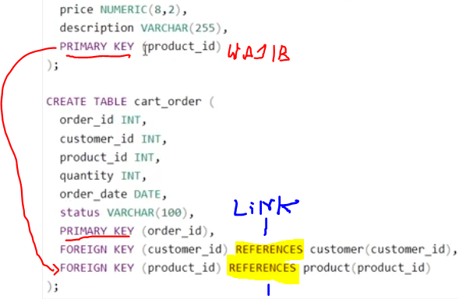

**The Primary Key and Foreign Key are used to link tables.**

3 Relational Model (Types of relationship) :

* One-to-many : record of data in a row 1 table is link to multiple record in different rows of another.
* One-to-one : one single records of one tables is associated with one single record of another table.
* Many-to-many : one record of one table with multiple records of another table

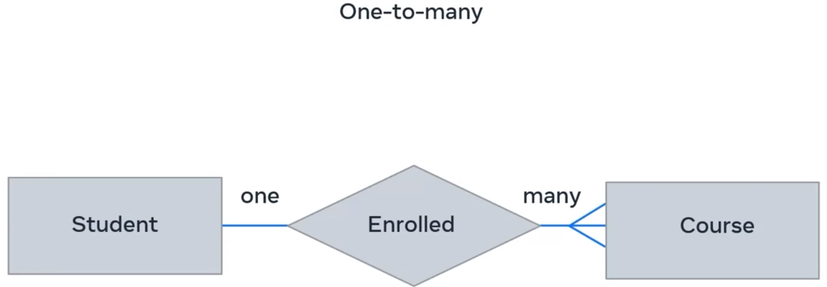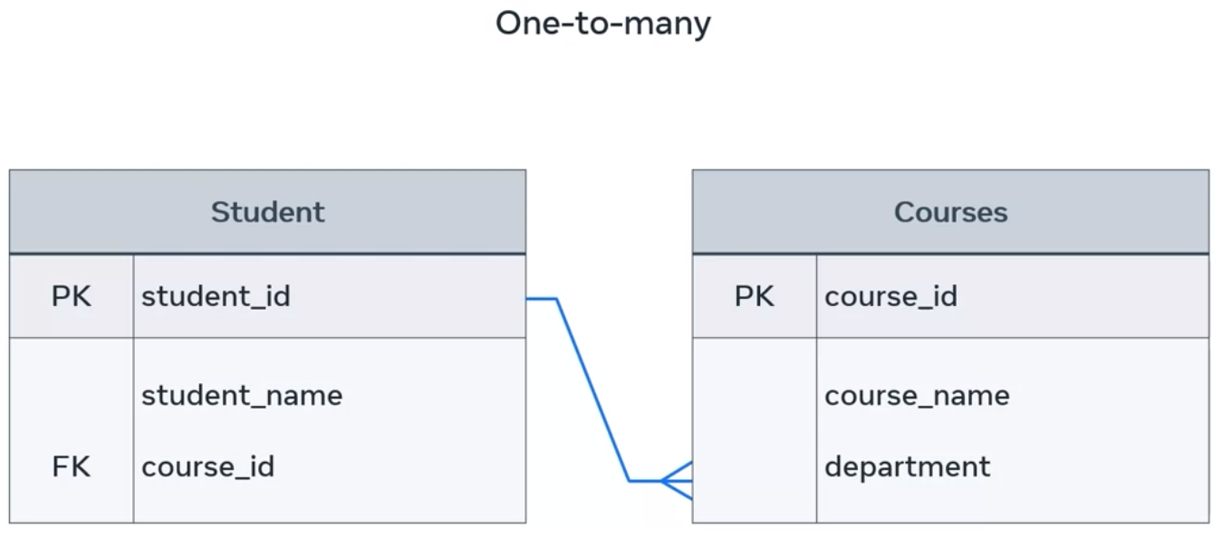

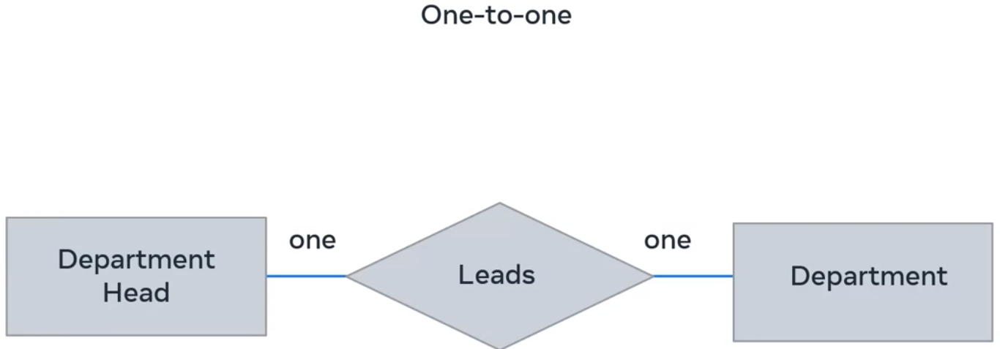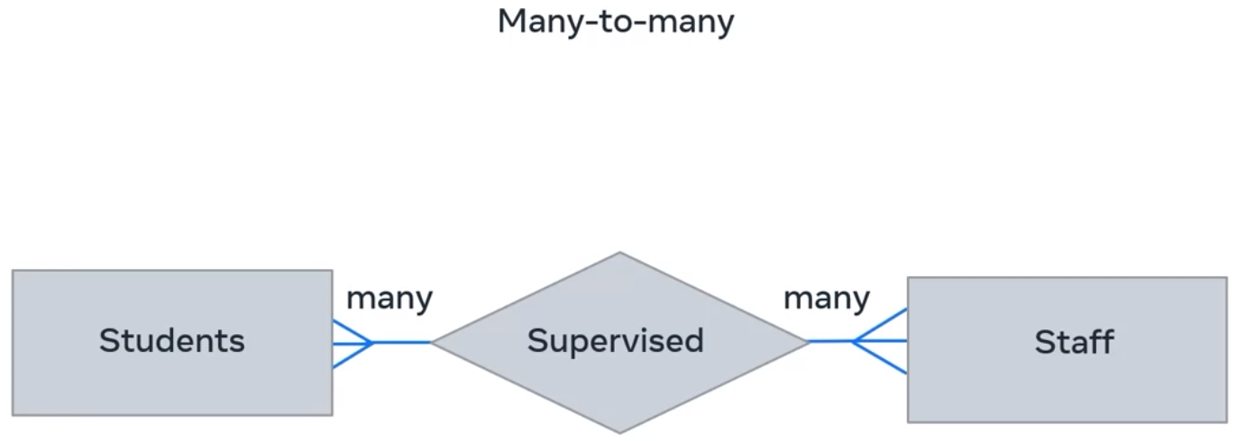

**What are constraints?**

In the relational model, every relation needs to meet three conditions. These three conditions must be met for a relation to be valid. They are called relational integrity constraints and they are:

1. Key constraints  : The key constraint revolves around the key attribute(s). In the relational model, a key attribute is an identifier that can be used to refer to a record. It must also be unique for each record.
2. Domain constraints  : Domain constraints are all about the requirement of inserting values that have a valid data type. There are a variety of data types that can be included within a table, namely numeric, text and data, in the case of the example
3. Referential integrity constraints  : A database has multiple tables that refer to one another. Referential integrity constraints are based on the concept of foreign keys. A foreign key is a key attribute present in a table, which is also a primary key of another table to which it needs to be linked.

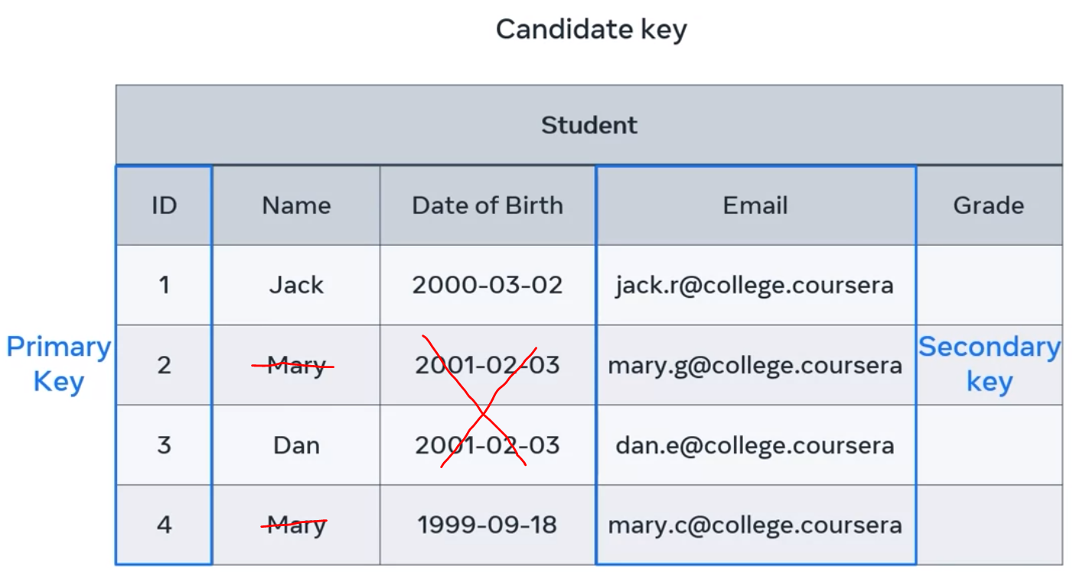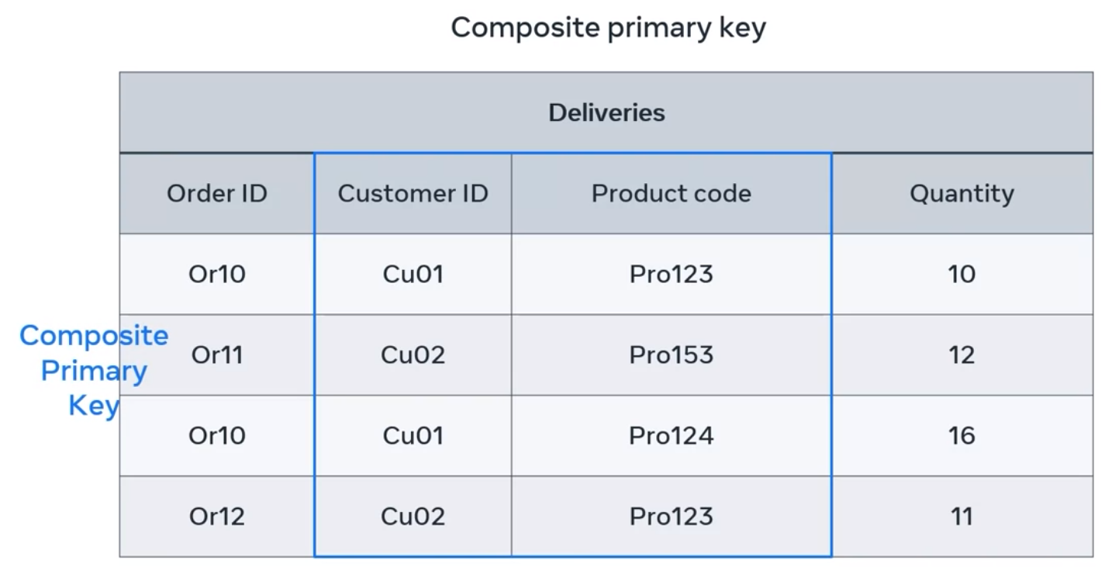

Foreign Key : columns used to connect tables, is one or more columns used to connect two tables in order to create cross-referencing between them.

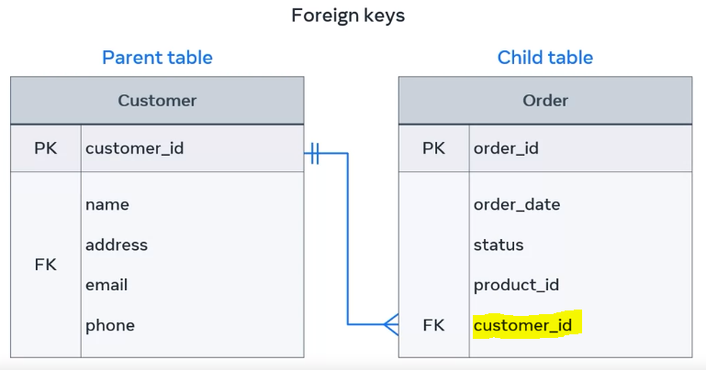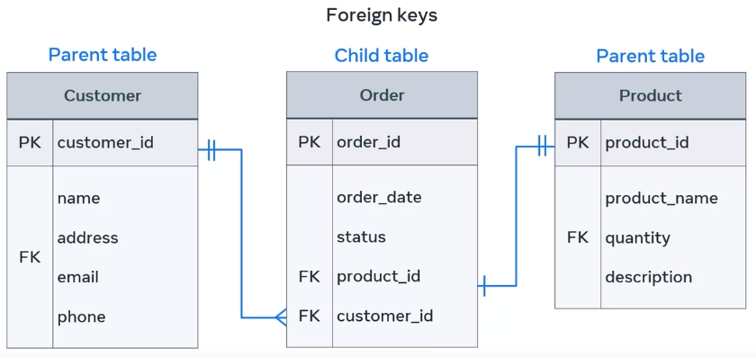

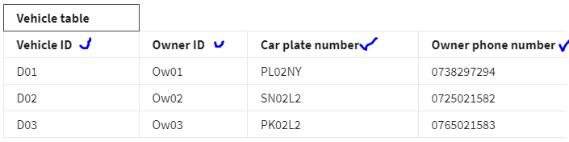

Could be 4 columns be Primary key. All columns are unique. But Car plate might be change, Phone number also might be change. 1 owner, could be have 1 more car. Car plate, phone number and owner ID might be change, so it is not good for Primary key. When you design a table in your database, you must make sure to choose a candidate key with a value that cannot change. The vehicle ID candidate key is unique and not expected to change so it should be your primary key. The constraint has been used in a proper way to define the email address as a primary key.

In example :

* CREATE TABLE Staff( Email VARCHAR(200) NOT NULL, Name varchar(255) NOT NULL, CONSTRAINT PK_Email PRIMARY KEY (Email));
* CONSTRAINT SalesID PRIMARY KEY (customerID, productID); means In this example there is only ONE PRIMARY KEY (SalesID). However, the VALUE of the primary key is made up of TWO COLUMNS (customerID +productID).

**Entities can be describe as an object that has properties which define its characteristics**. An entity can be anything that represents a single object in a database, such as a place or a person. In a relational database system, each interesting object in a project could be considered an entity. The table name represents the entity name, for example Deliveries. And each column represents the entity-related attributes such as ID, Customer name, delivery status**. Each entity has a set of attributes that hold relevant information about it. Each attribute must be defined with a data type.** **The entity relationship model is based on two key concepts: Entities and relationships**

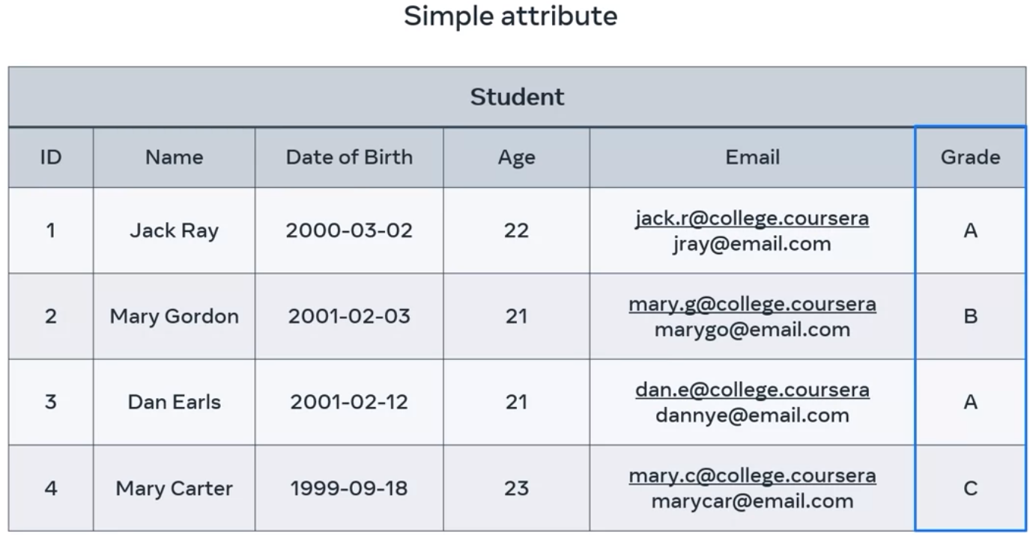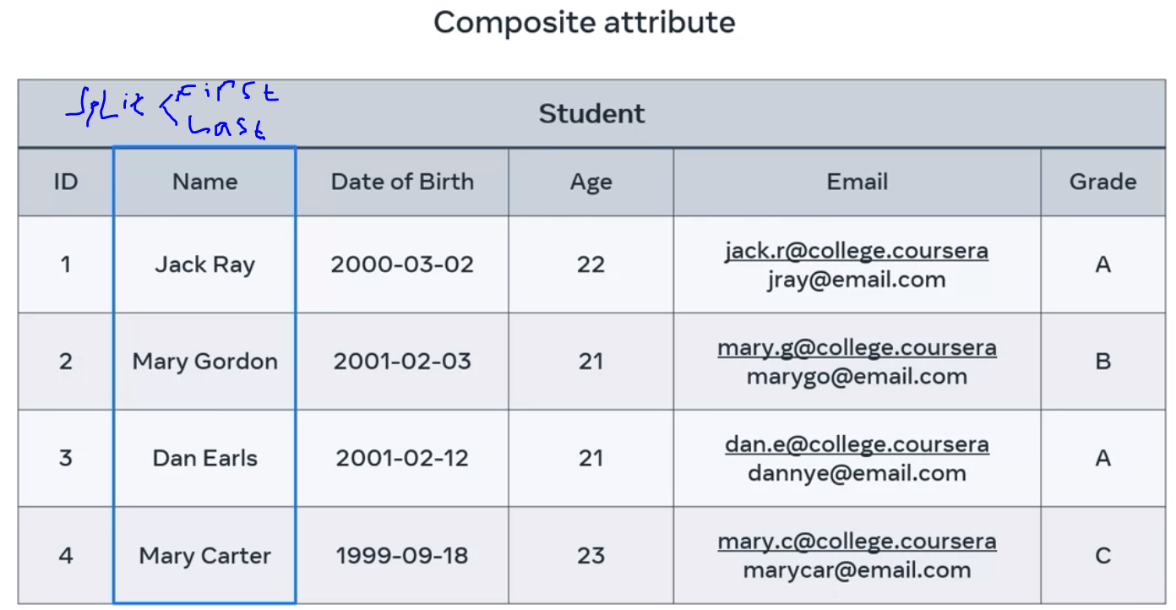

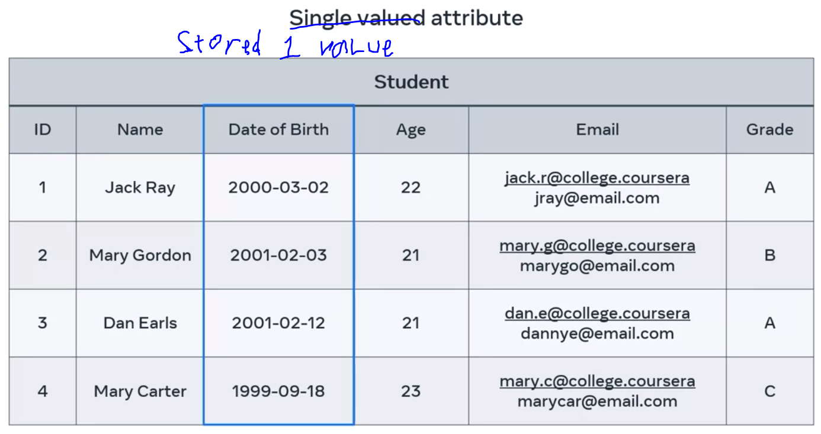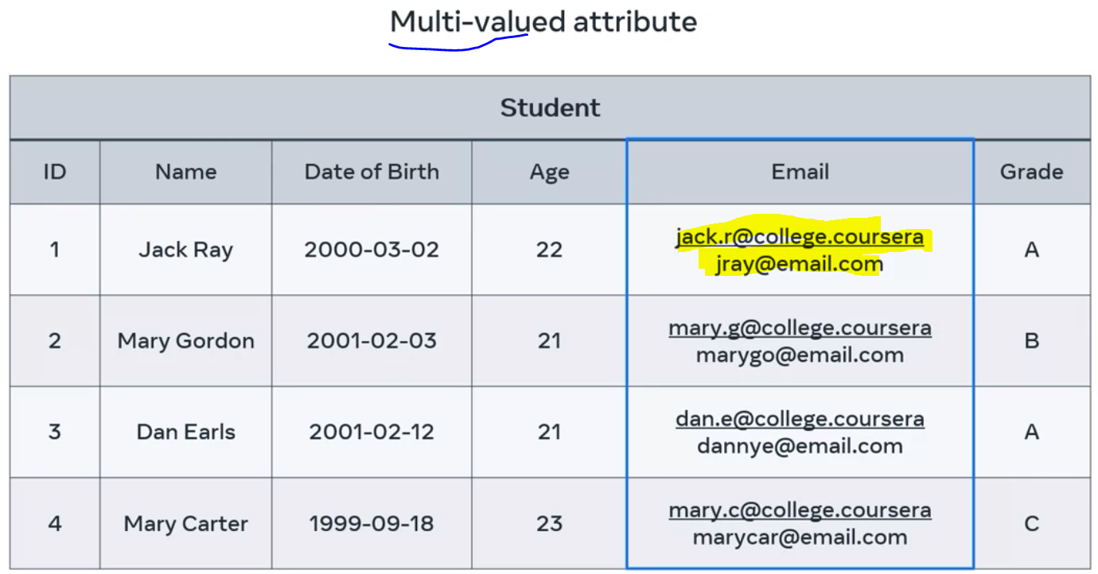

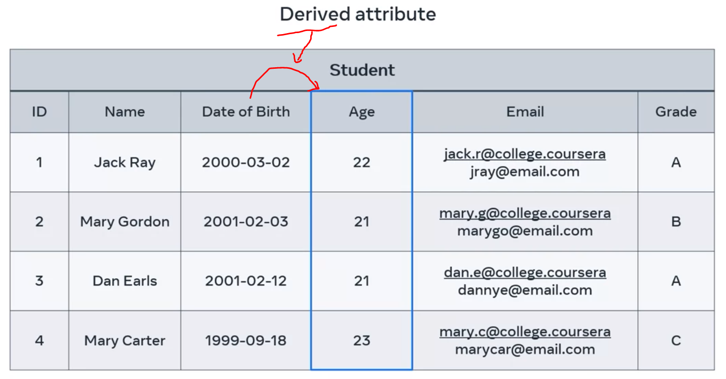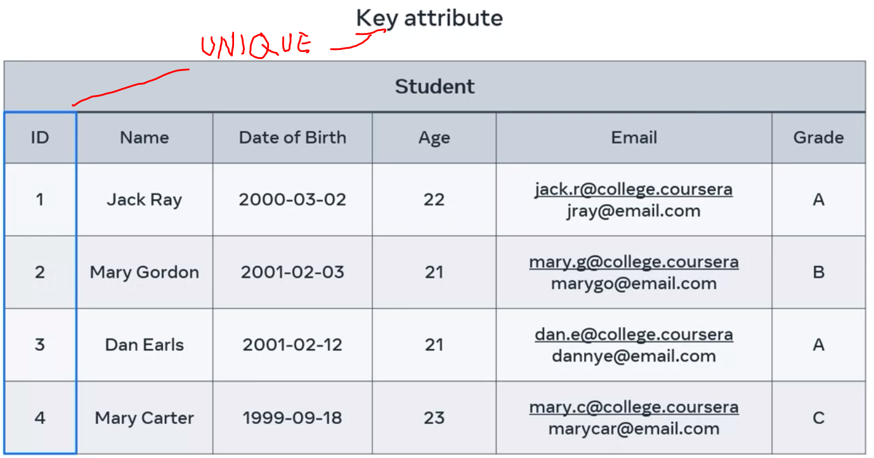

Database Normalization is process for structuring tables that minimizes challenges,by reducing data duplication, avoid data modification multiplication and helping to simplify data queries from database.

A lot of information within 1 Tables, makes it difficult.

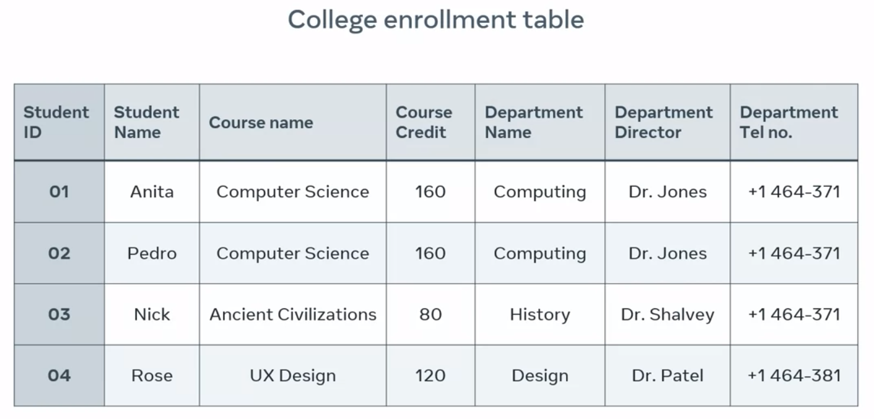. 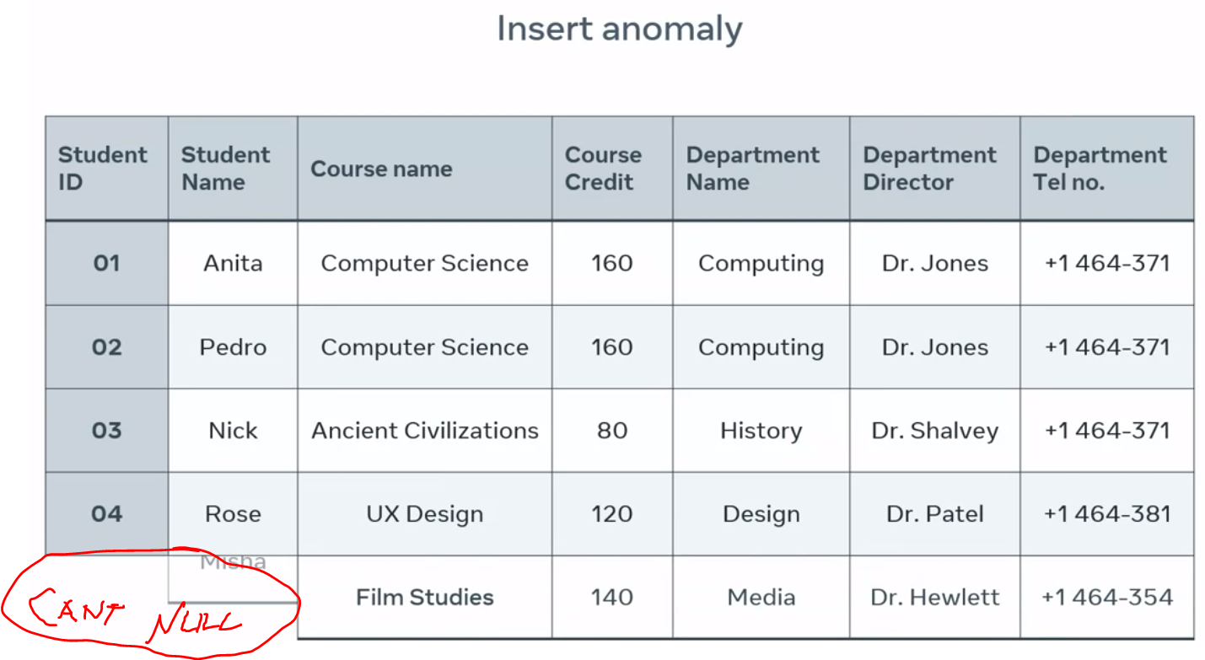

* Insert anomaly : insertion of one record leads to the insertion of several more required data sets. We must fill student ID and student name, if we add course name. IT IS DOESN’T GOOD;
* Update anomaly ; updating a record in a table column requires further updates in other columns.
* Deletion anomaly : deletion of one record leads to the deletion of several more required data sets. Want to delete some columns, effect deleted all deleted.

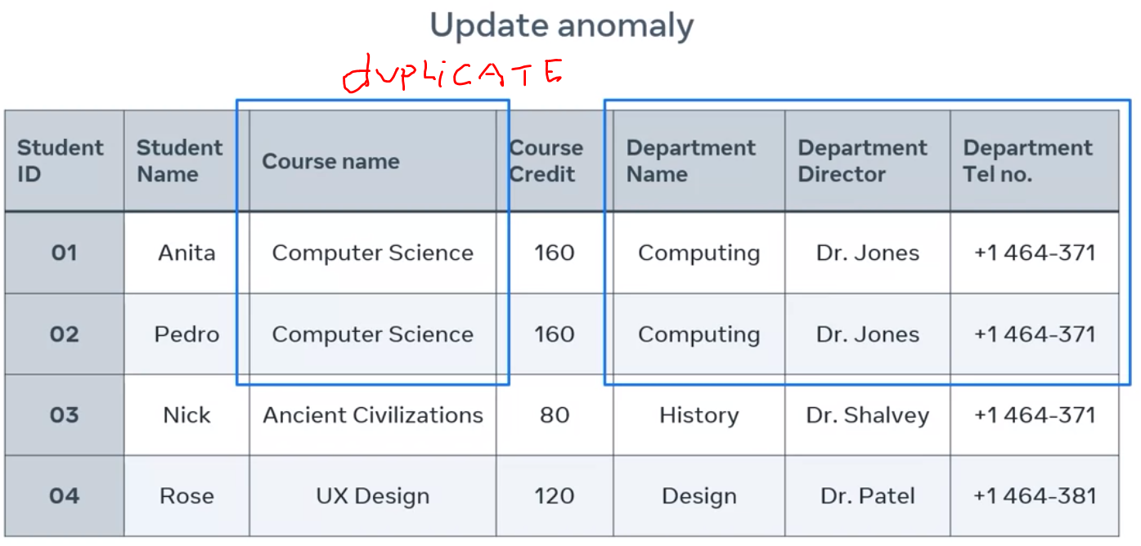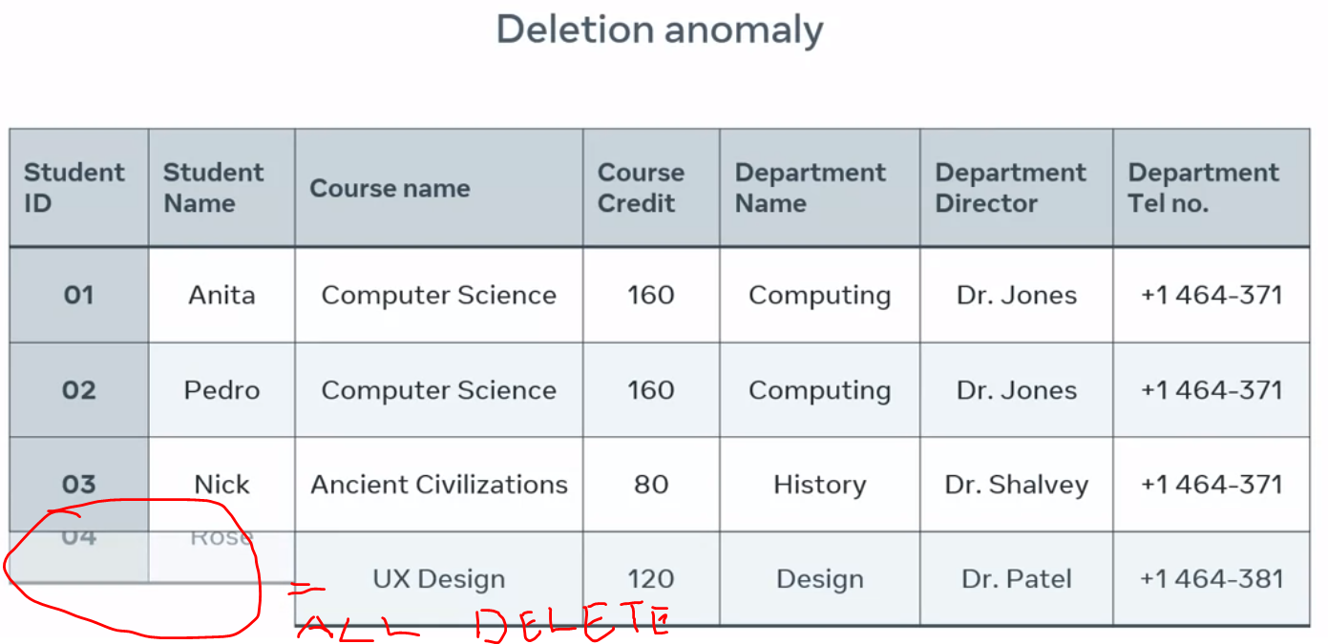

USE NORMALIZATION to optimizes the database design by crating a single purposes for each table.

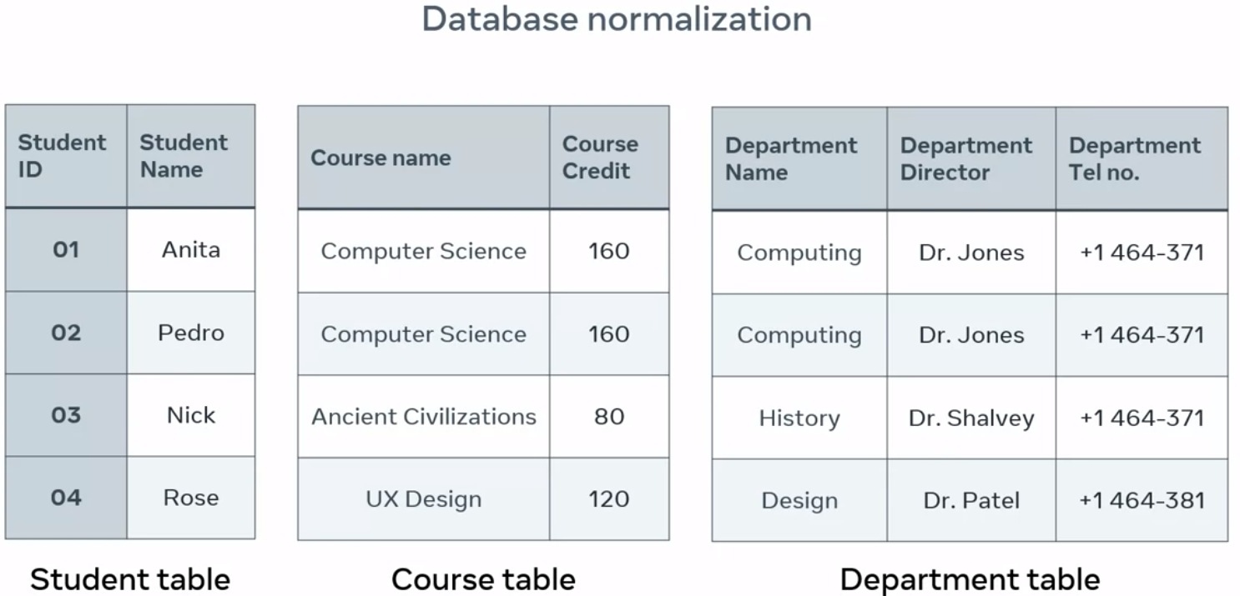

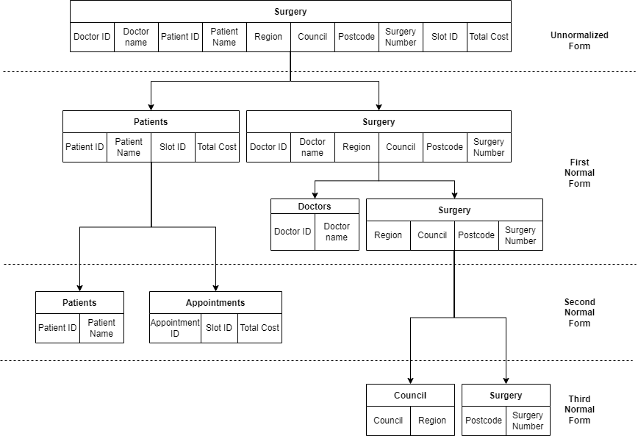

* 1NF : **enforces data atomicity** and eliminates unnecessary repeating groups of data in database tables.
  + Data atomicity ensuring that there is only one single instance value per column field (One value per field).
  + Data redundancy
  + Data inconistency
* 2NF : Following partial dependency.
* 3NF : Transitive dependency occurs when a non-key attribute determines the values of one or more other attributes. A database must be in first and second normal form before it can be in third normal form. Database can contain any instances of transistive dependency.

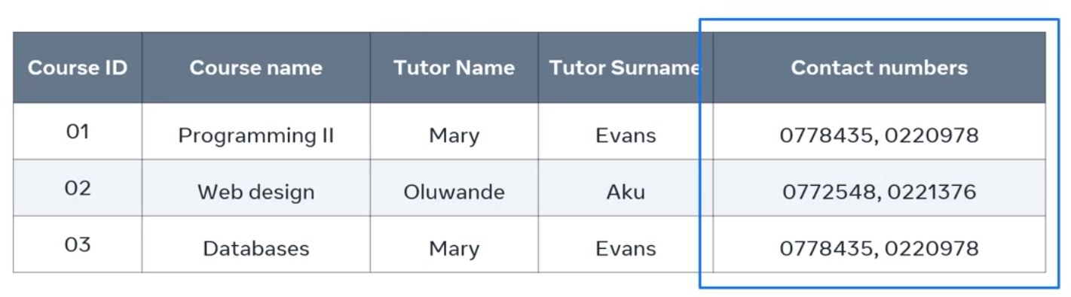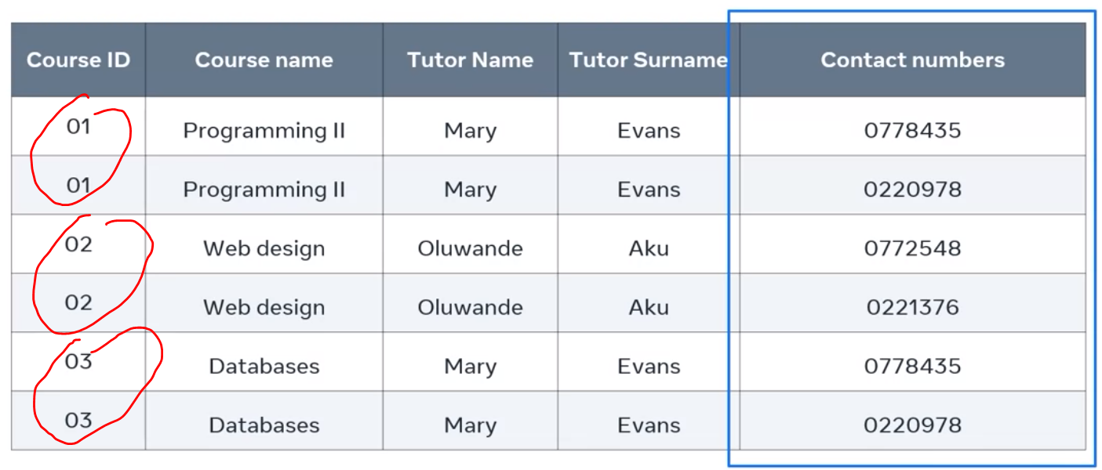

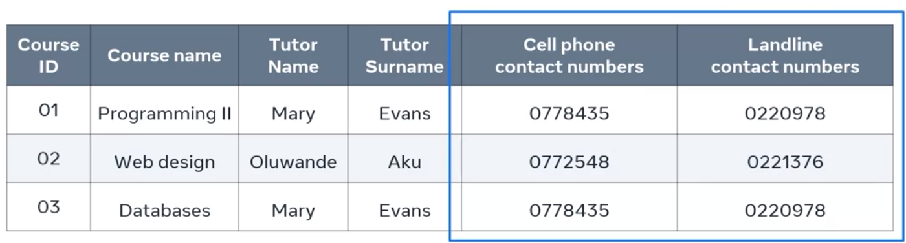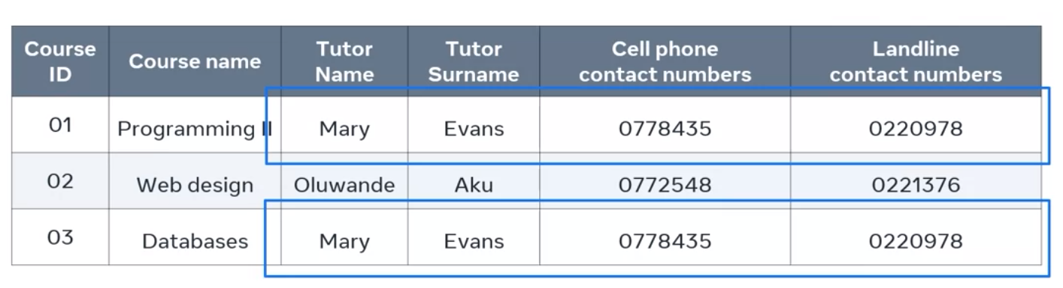

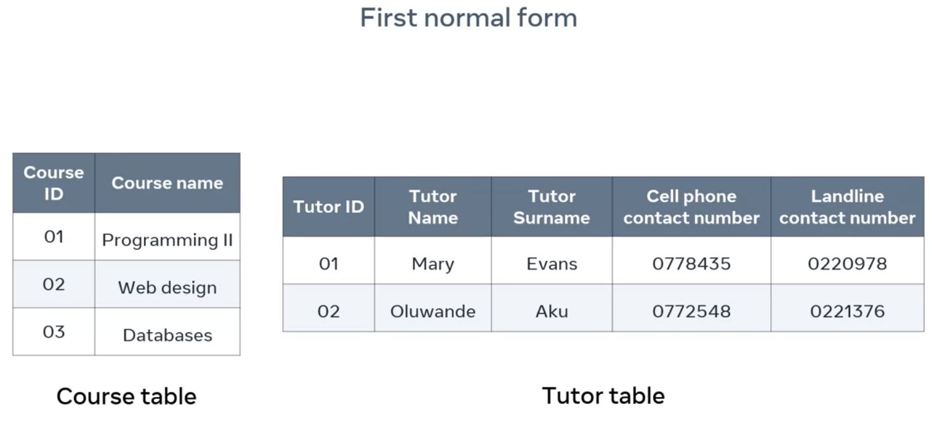

**1NF and then 2NF,** to ensure you have a proper structure and reduce duplication.

* **Functional Dependency** : Relationship between two attributes in a table. The unique value of a column in a relation determines the value of another column. Primary key is dependency. If table has 3 columns (column A, B, and C). For Example A is PK so the table functionally dependent on the column A. Column A it’s the only column that can be used to return specific data.
* **Partial Dependency** : A table with a composite primary key. This is the key that consist of a combination of two or more columns.
* **Transitive dependency** : A non-key attribute can not be functionally dependent on another non-key attribute. In other word, non-key attributes can not depend upon one another. Remember A key attributes is an atttibute that helps to uniquely identify a raw of data in a table.

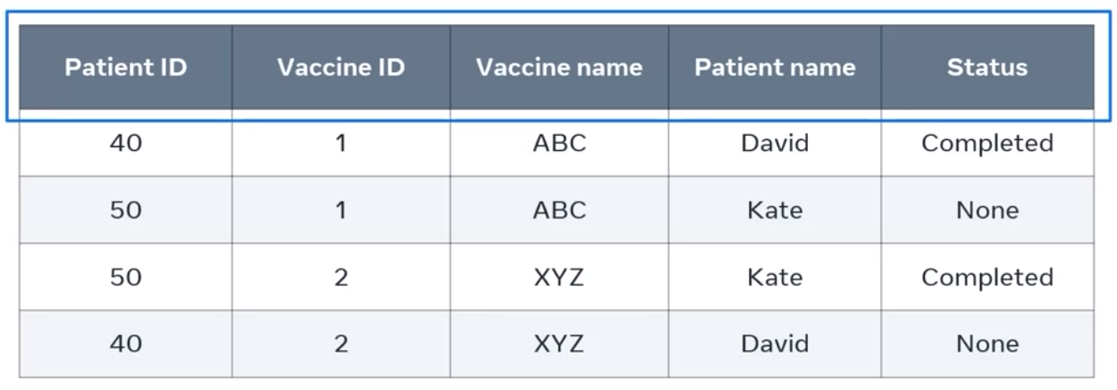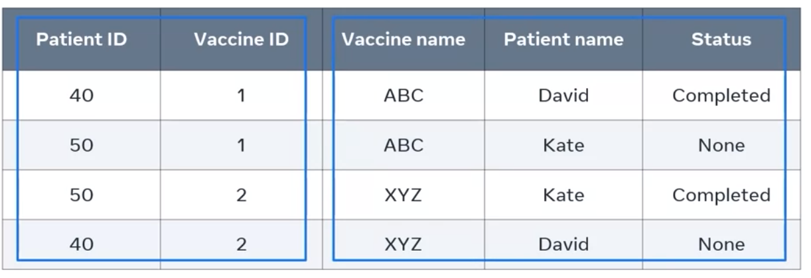

There is no single Primary key. IT’s best to combine both the patient ID and Vaccine ID columns as a composite primary key to create a unique value in each record.

All non key attributes (vaccine name, patient name, status) must depend on the entire primary key value (which is patient ID and vaccine ID) – composite primary key. That means there is a functional dependency between .

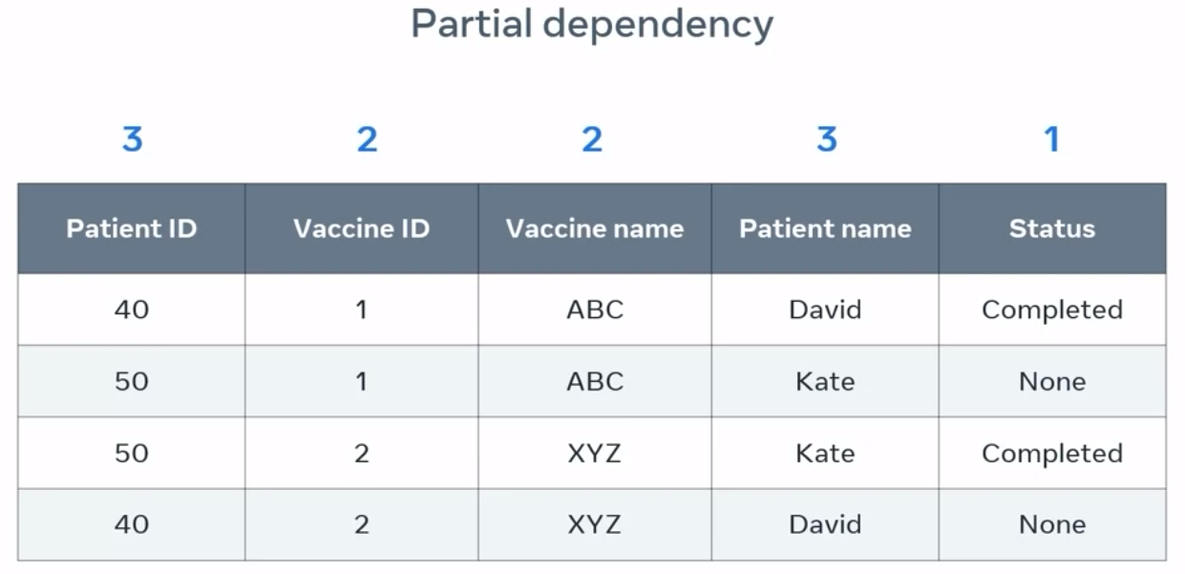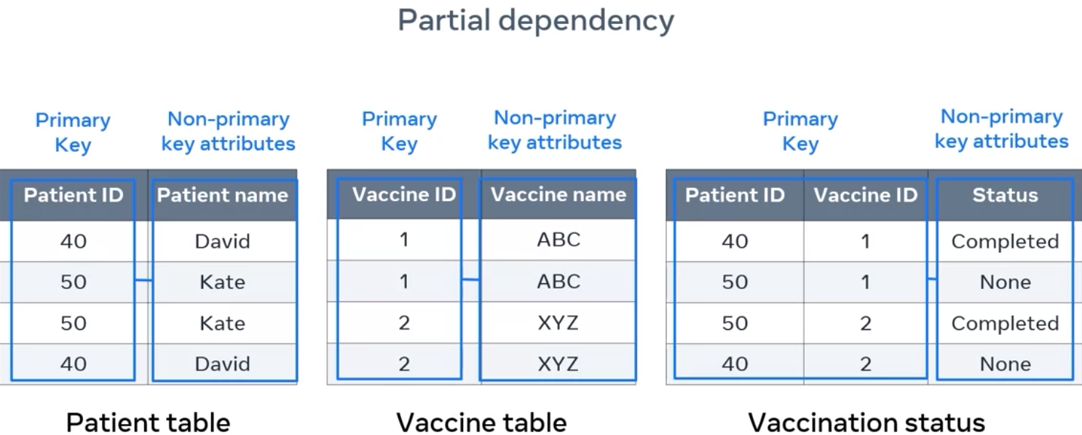

**Transitive dependency mean**s Column A determines column C through column B.

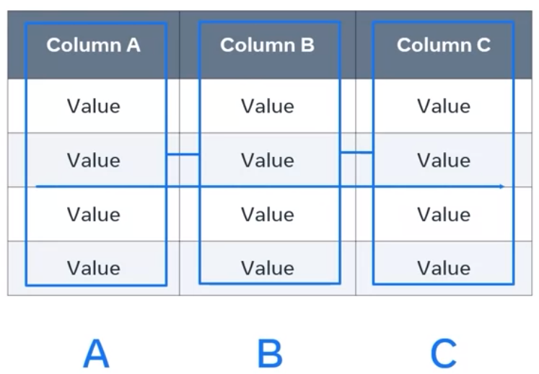 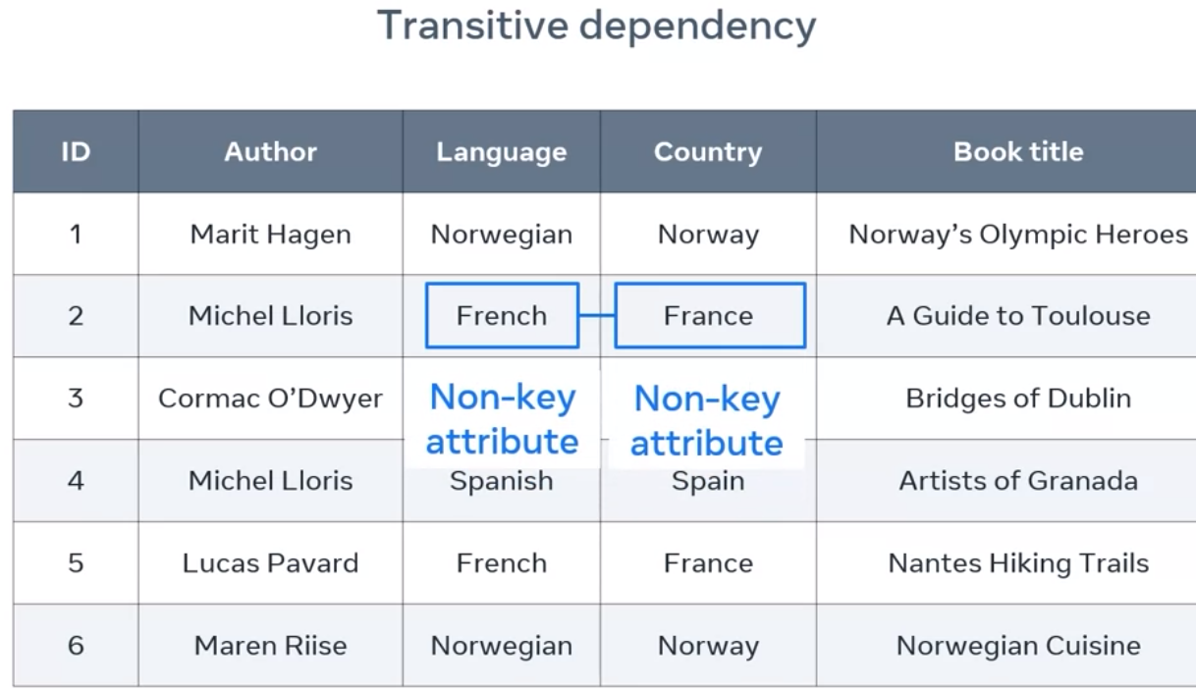 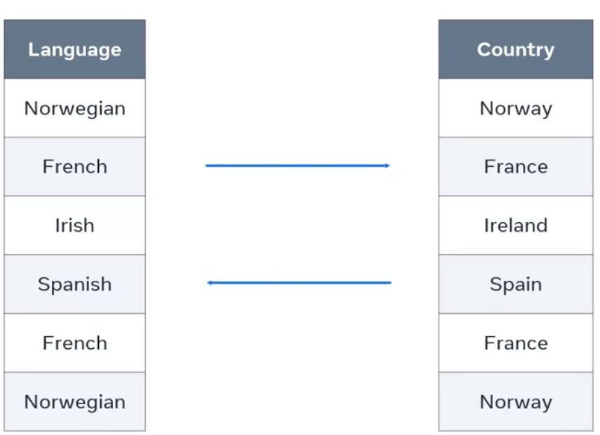

* Language determines country, and country determines language.
* Author name can not determines book title. (rest of attributes, author name, and book title only depend on the Primary Key)
* Author name can not determines language (rest of attributes, author name, and book title only depend on the Primary Key)

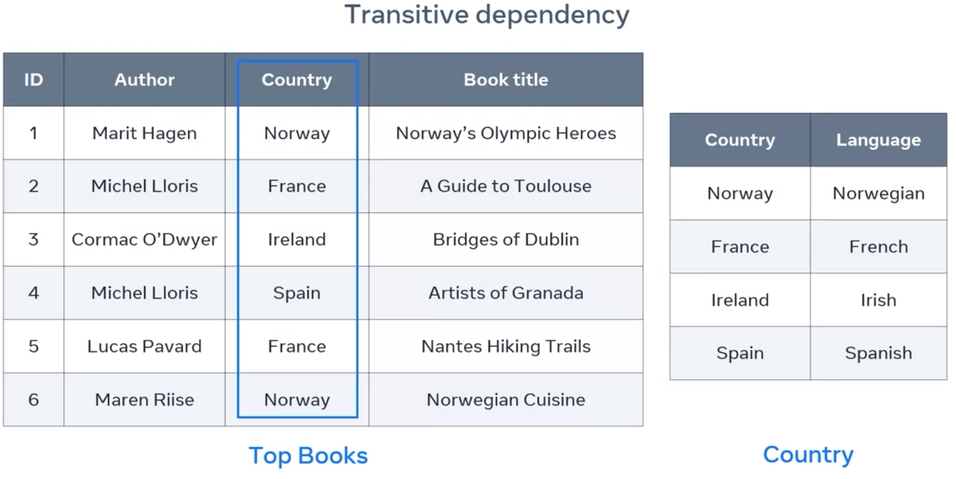 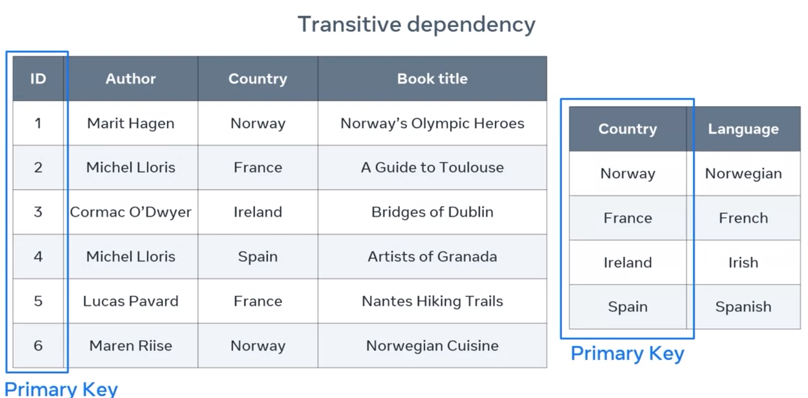

1. A logical database schema shows how the data is organized in tables and how records of data are related in these tables.
2. The normalization process aims to reduce the negative effects of the update anomalies, insertion anomalies and deletion anomalies.
3. Identify the issue with the following table of data in accordance with the rules of first normal form criteria : duplication data
4. The credits value is dependent on the subject value which is a subset of the composite primary key. This is called partial dependency that violates the second normal form.
5. A database relation is in second normal form if it is in first normal form and every non key attribute is _FULLY__ functionally dependent on the primary key
6. Database normalization is a progressive process.

The following resources introduce key concepts of database design and anomalies. They also provide good examples of first, second and third normal forms :

1. <https://www.databasestar.com/database-normalization/>
2. <https://www.bbc.co.uk/bitesize/guides/zc93tv4/revision/2>
3. https://opentextbc.ca/dbdesign01/chapter/chapter-12-normalization/
4. CREATE DATABASE SportsClub;
5. CREATE TABLE Players (playerID INT, playerName VARCHAR(50), age INT, PRIMARY KEY(playerID));
6. INSERT INTO Players (playerID, playerName, age) VALUES (1, "Jack", 25);
7. Karl
8. SELECT playerName FROM Players;
9. UPDATE Players SET age=22 WHERE playerID=3 ;
10. DELETE FROM Players WHERE playerID=4;
11. SELECT PlayerID % 2 FROM Players;
12. SELECT Name FROM Players WHERE Age > 25;
13. DepartmentID VARCHAR(50), FOREIGN KEY (DepartmentID) REFERENCES Department(DepartmentID);
14. A record
15. FullName VARCHAR, Player INT
16. level INT DEFAULT 1;
17. TRUE Database constraints are used to limit the type of data value that can be stored in a table.
18. True
19. False
20. It displays the results ordered by country first, then players name.
21. False, 2NF
22. Diagram 2
23. One to Many

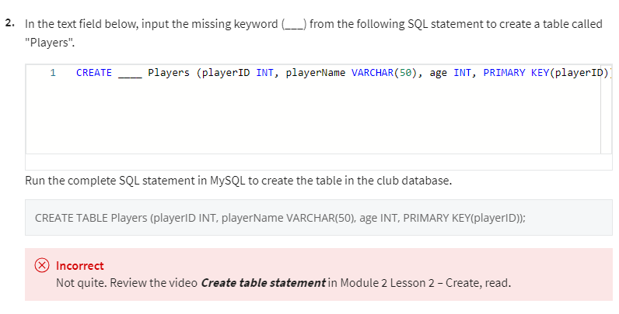 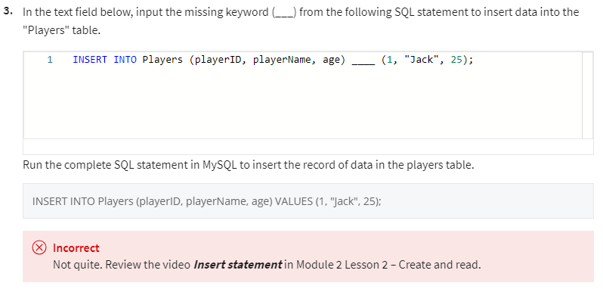

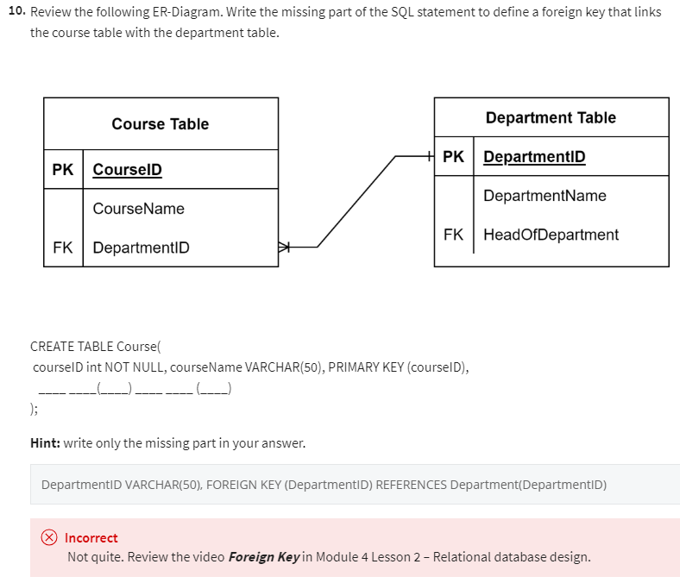

-----------------------------------------------------------------------------------------------------------------------------------------------------------

-----------------------------------------------------------------------------------------------------------------------------------------------------------

CHAPTER IV – WORKING WITH STRING VARIABLES

Retrieve the data in the format you need. CLIENT vs SERVER FORMATTING.

String functions :

* Concatenate : For linking things together.
* Substring : Leading or trailing space from a string(everything off the front & the back or trim it from the right or

left). Consist of TRIM, LTRIM, RTRIM.

* Trim : Function that allows you to pull apart just a portion of the string that you are looking at. Substring

returns the specified number of characters from a particular position of a given string.

* Upper :
* Lower :

|  |  |  |
| --- | --- | --- |
|  |  |  |
|  |  |  |
|  |  |  |

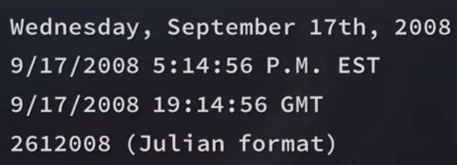

WORKING with Data variables is more difficult things in SQL: Each Data management system uses it’s own variety of data type. As long as your data contains only the date portion, your query will works as expected. However, if there is a time portion (time stamps) is involved, it’s getting more complicated. Why?? **Because there is a lot of different formats for that**. See examples.

Understanding how it’s formatted before you start working with it. KNOWING how to change and manipulate it is important.

|  |  |
| --- | --- |
| SQL Lite support 5 different date and time functions. | Time String (extract **from the date time function**) |
|  |  |

**Date and Time String Examples (STRFTTIME – String format time function)**

it's used to extract certain elements of a date/time string.

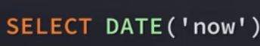  

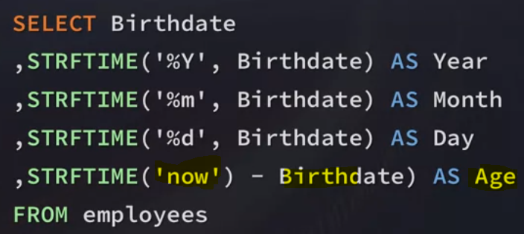 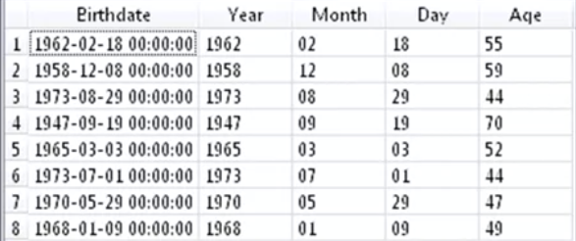

**CASE STATEMENTS** is built in function that mimic an if-then-else kind of statement found in most programming languages. This can be used in **SELECT, INSERT, UPDATE, and DELETE** Clause / Statements.

Starting with CASE , and then WHEN, and then you will have a condition (IF). Then after you say the condition, you put then and what the result expression will be. SO, you could have multiple cases when it’s a certain expression and what you want the result to be, and that could go on for a while. When you are done with that, if the expression declared in the when part of the statement is not one of those cases then at your option, you can elect to say what else (ELSE) the result would be and then you end your expression. This shows just an outline of what it would look like.

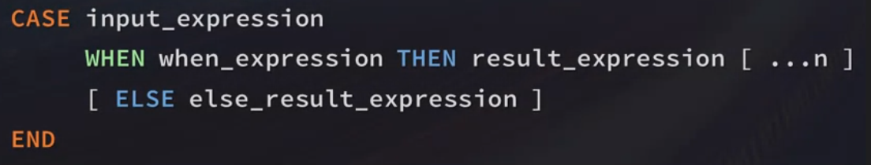 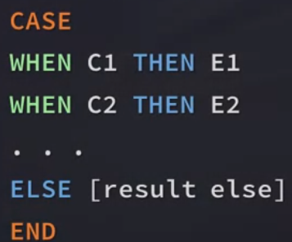

It’s a BINARY Variable (CALGARY or OTHER) for a categorical variable (CITY).

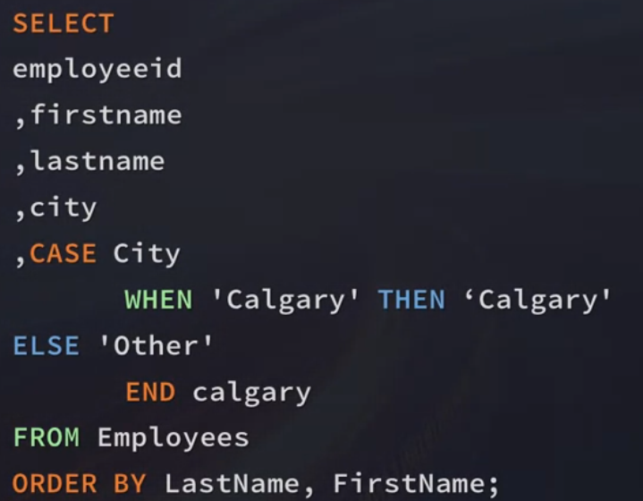 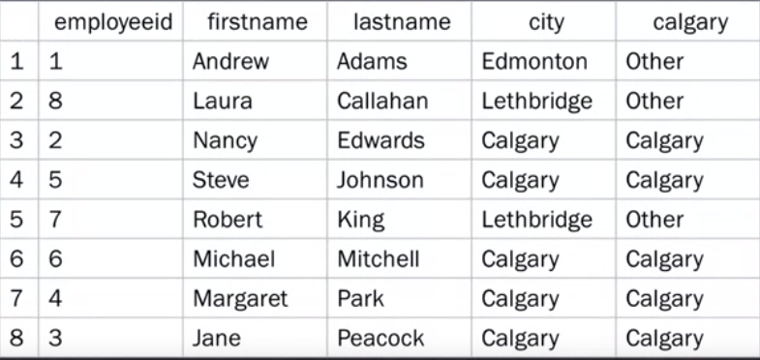

**CLASSIFY them based on number of bytes they (TRACKS) have.**

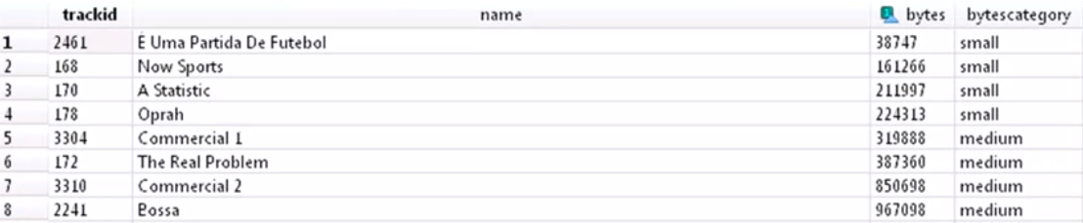 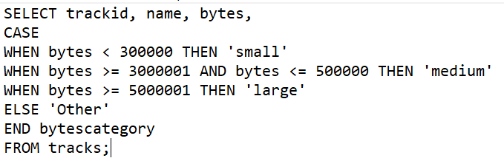

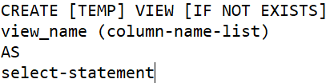**VIEWS**

1. A stored query
2. Can add or remove columns without changing schema
3. Use it to encapsulate queries
4. The view will be removed after database connection has ended.

We are always combining data from multiple sources or transforming it in some way. Instead of creating a whole new table, sometimes we can create the illusion of a table by using a view. A view is esstentially a store query and it helps us clean up queries and simplify when we have to write. You are not actually writing the query to the database or anything. **What you are doing is you are kind of storing it for the time being (duration of session) won’t be a permanent FIXTURE in your SQL COde.**

We want to get a count of how many territories each employee has. From ER Diagram, this information is separated out from each other. On that view, I can just run a simple count on the number of territories, so I will create my_view. Then the AS is really the select statement. Remember we have used AS as an alias to say what we want our column name to be. But now, you are saying what do you want in all of that table. Then AS going to be a select statement for what I want in that view.

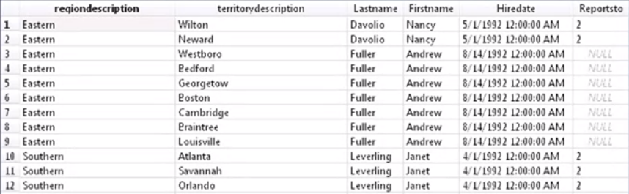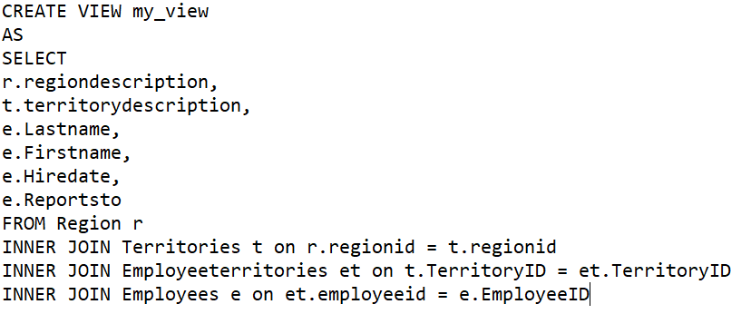

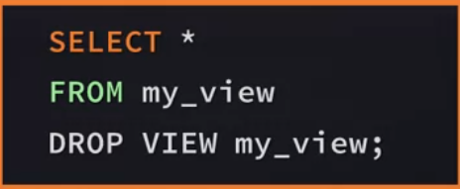 **to actually view the data using SELECT statement.**

**GET A COUNT of HOW MANY TERRITORIES EACH EMPLOYEE HAS**

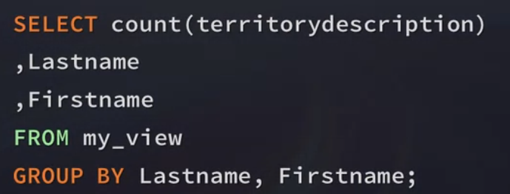 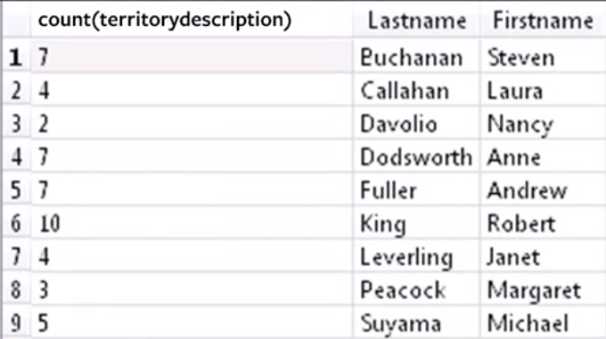

Views are helpful because you are creating a view of a table but not actually writing data to that table. And also to create a stepping stone in multilevel queries. Ie. Query that counts the number of sales that each person has made. You could then write a query that groups the salespeople into a particular group. And then you can count the sales of that group as well.

VIEW :

* Instead of creating a whole new table, we can create the illusion of a table using a View.
* Sometimes when you're in a sticky situation and don't really know how to solve it, views can help you simplify your queries.
* You're not actually writing the query to the database or anything. What you're doing is you're just kind of storing it for the time being.
* This is helpful because you're creating a view of a table but not actually writing data to that table, so you avoid the limitations.

**DATA GOVERNANCE and PROFILING** (when it comes to writing really clean and quick queries, where you are getting this data and how you actually want to get it back.)

Profiling your data is where you are looking **at either descriptive statistics** (MIN, MAX, AVG, STD Deviation) or different information on the data. Important because we’ve talked about how you need to understand your data first, before you start querying it. And it’s important to begin to understand your data. For example how many number of rows, or when the object or table was last updated, how many number of distinct value, number of rows with NULL values.

Governance best practices is understand your read and write capabilities, clean up your environment and understand your promotion process.

1. Extracting the data from some storage system, analyzing it and then maybe writing back a prediction to the database.
2. Start with DATA UNDERSTANDING, spent much time to understand and explaining modeling ER Diagrams and discussing the relationship in your data. REALLY KIND of a combination of data understanding and business understanding.
3. Investing time to understand your subject will help later during the data analysis (understand the relationships and the dependencies).
4. BUSINESS OR SUBJECT Understanding

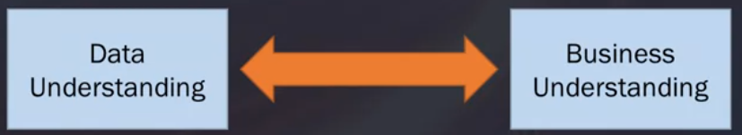

1. BEWARE of THE UNSPOKEN NEED. These are certain logical exclusions. Means to add more questions DEEP. Which customer, what products, what is should be excluded,,etc…
2. The solution for UNSPOKEN NEED is frequently need to look at the data to get questions. And then you need to go back to the business to understand the problem better.
3. If you really understand your data and understand the problem, writing the queries is just like filling in the blanks.
4. **TO SLOWLY DO**

----------PROFILING DATA----------

1. Always start with SELECT clause or Statement.
2. Get into the DETAIL of your data, create a data model and map the fields and tables you need. CONSIDER joins and calculations. ALSO understand any data quality or format issues
3. START with simple/SMALL, means start with just one table, add in more data, add in another table, check your results.
4. If SUBQUERY, always start with the innermost query and then work out and build.
5. Don’t wait to test your query until you’ve combined multiple sources together and you have all your calculations done and finished.
6. For troubleshoot, start at basic things first. Slowly start to build it back up in order to figure out where things went wrong.
7. Format correctly and commenting nicely/necessary. You never know when you are going to need to revisit your query or you are going to need to hand it in to someone else and they need to edit to from there.
8. Always review old queries, are the business rule different ,does anything need to be updated.
9. **START WITH DATA AND PROBLEM UNDERSTANDING. Will save time, slowly DO.**

**SQL PUZZLES :** [**https://blog.sqlauthority.com/category/sql-puzzle/**](https://blog.sqlauthority.com/category/sql-puzzle/)

**SQL ZOO :** [**https://sqlzoo.net/wiki/SQL_Tutorial**](https://sqlzoo.net/wiki/SQL_Tutorial)

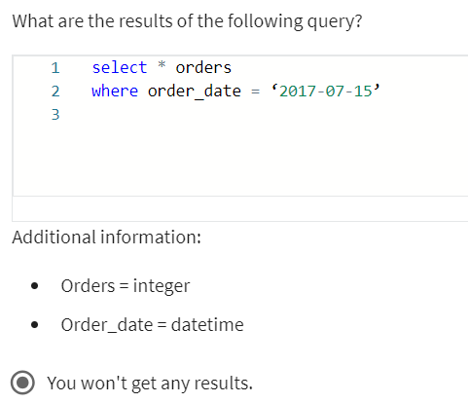 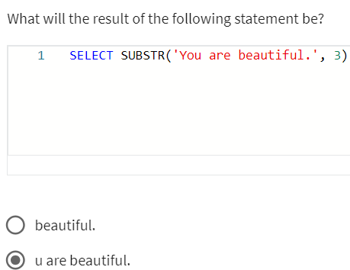

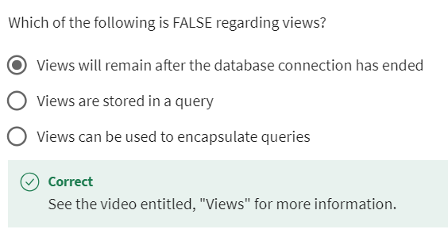 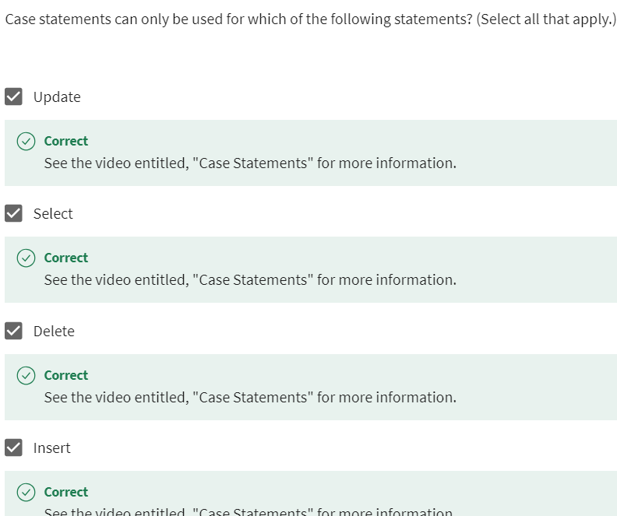

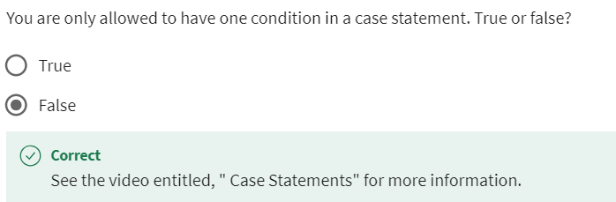 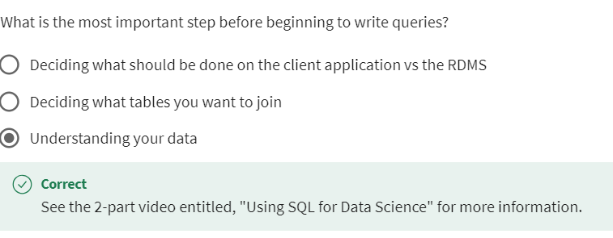

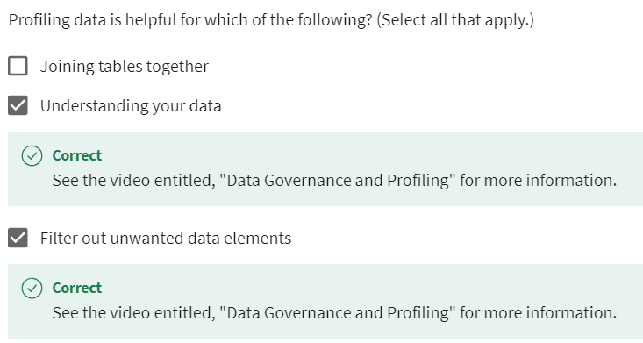 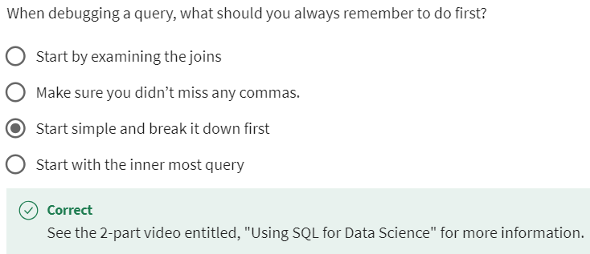

1. Pull a list of customer ids with the customer’s full name, and address, along with combining their city and country together. Be sure to make a space in between these two and make it UPPER CASE. (e.g. LOS ANGELES USA)

SELECT CustomerId, FirstName, LastName, Address, UPPER(City), Country, PostalCode

FROM Customers

1. Create a new employee user id by combining the first 4 letters of the employee’s first name with the first 2 letters of the employee’s last name. Make the new field lower case and pull each individual step to show your work. - 7 robe ki

SELECT EmployeeId, LOWER(SUBSTR(FirstName,1,4)), LOWER(SUBSTR(LastName,1,2)), LOWER(SUBSTR(FirstName,1,4) || ' ('||SUBSTR(LastName,1,2)||')')

FROM Employees;

1. Show a list of employees who have worked for the company for 15 or more years using the current date function. Sort by lastname ascending - PEACOCK

SELECT EmployeeId, FirstName, LastName, HireDate, STRFTIME (2024 - HireDate ) AS Date

FROM Employees WHERE Date > 15

ORDER BY LastName ASC;

1. SELECT * FROM Customers WHERE FirstName is NULL; - FAX, Phone, Company, PostalCode
2. Find the cities with the most customers and rank in descending order.

– SaoPaulo, London, MountainView

SELECT CustomerId, Address, City, State, COUNT(City)

FROM Customers

GROUP BY (CITY) --check duplicate numbers in CITY

ORDER BY COUNT(CITY) DESC

;

1. Create a new customer invoice id by combining a customer’s invoice id with their first and last name while ordering your query in the following order: firstname, lastname, and invoiceID.

* AstridGruber273 / 296 / 370

SELECT Customers.FirstName, Customers.LastName, Invoices.InvoiceId

FROM Invoices INNER JOIN Customers ON Invoices.CustomerId = Customers.CustomerId

ORDER BY Customers.FirstName ASC

;

1. Find the average honey production for the year 2022. – 3133275

SELECT AVG(Value) FROM honey_production WHERE Year = 2022;

1. Get the state names with their corresponding ANSI codes from the state_lookup table. What number is Iowa? – 19

SELECT * FROM state_lookup;

1. Find the highest yogurt production value for the year 2022. - 793256000
2. Find states where both honey and milk were produced in 2022. Did State_ANSI "35" produce both honey and milk in 2022? – NO

SELECT DISTINCT h.State_ANSI FROM honey_production h

JOIN milk_production m ON h.State_ANSI = m.State_ANSI

WHERE h.Year = 2022 AND m.Year = 2022;

1. Find the total yogurt production for states that also produced cheese in 2022.-1171095000

SELECT SUM(y.Value)

FROM yogurt_production y

WHERE y.Year = 2022 AND y.State_ANSI IN (

    SELECT DISTINCT c.State_ANSI FROM cheese_production c WHERE c.Year = 2022

);

1. Find the total milk production for the year 2023. – 91812000000

SELECT SUM(Value) FROM milk_production WHERE Year = 2023;

1. Show coffee production data for the year 2015. What is the total value? - 6600000

SELECT * FROM coffee_production WHERE Year = 2015;

1. **91812000000**
2. **13 atau 14..masukin** 13 **karena 1 NULL**

**SELECT * FROM cheese_production *cp***

**WHERE (Period = 'APR' AND "Year" = 2023) AND Value > 100000000**

**ORDER BY State_ANSI**

**;**

1. **7600000**

**SELECT * FROM coffee_production *cp***

**WHERE YEAR = 2011**

**;**

1. **3133275**

**SELECT AVG(Value) FROM honey_production *hp***

**WHERE YEAR = 2022**

**;**

1. **12**

**SELECT * FROM state_lookup *sl* ;**

1. 4889000

**SELECT \***

**FROM cheese_production *cp***

**GROUP BY State_ANSI**

**;**

1. **1171095000**

**SELECT *, SUM(Value) FROM yogurt_production *yp***

**WHERE (Year = 2022);**

**4708634000**

**SELECT SUM(Value)**

**FROM cheese_production *cp***

**WHERE "Year" = 2023;**

1. 7 (3,7, 11, 14, 43, 52)

**SELECT DISTINCT State_ANSI FROM milk_production *mp***

**ORDER BY State_ANSI ;**

1. No
2. 4152970.437017885

**SELECT *, AVG(Value) FROM honey_production *hp***

**WHERE Value > '1000000'**

**ORDER BY Value DESC**

**;**